This collection of short stories is devoted to the coming great holiday — the 75th anniversary of our Victory in the Great Patriotic War and presents the works of 4 students of group ISC10-61.
The 75th anniversary of the Great Victory over Nazi Germany in the Great Patriotic War is a special day. It’s a wonderful holiday different from all other holidays. It is a national holiday and at the same time a very personal one because that terrible war affected the lives of every family in every street in every town of this country.
We would like to tell the stories of the most ordinary families, the most common heroes.
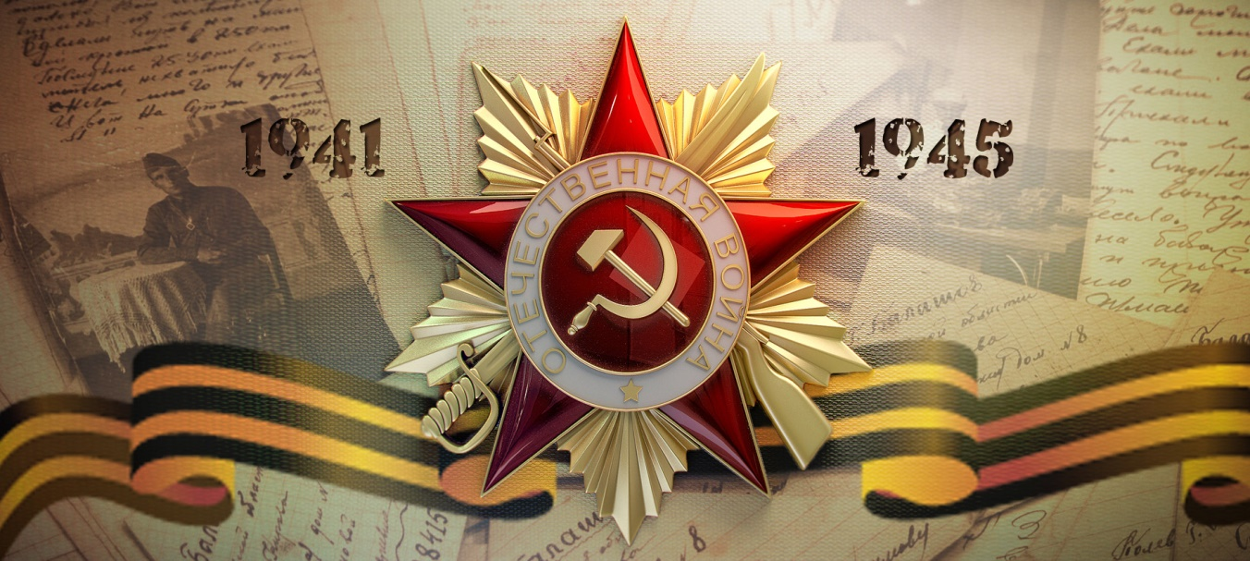

The first story
The author – Mikhail Konyukhov
Leonid Vladimirovich Konyukhov
1928 - 2009
The Great Patriotic war was a difficult time. It was very difficult for all people. The war was bloody and brutal. Many soldiers and civilians were killed. In the death camps, people were subjected to terrible torments. The rear was hungry. Women were afraid for their husbands and children who were fighting at the front.
I want to tell you about my Grandfather, who lived through these times in his childhood. My paternal grandfather was Leonid Konyukhov was 13 years old when the war started. His father went to the front in the first days of the war, and his mother worked in a hospital all day long in Leningrad. With the younger brother who was 4 years old, they remained in the village of Dubrovka captured by fascists . In that village there were only old men, women and children. For the fascists, this village was a small transit point where they could rest. They didn’t kill anyone, but instead asked to set the table, provide a place to sleep and prepare a bath.
When the fascists were sitting and drinking moonshine in their homes, my grandfather and his friends drained gasoline from their vehicles, punctured tires of their motorcycles. They even managed to steal most of the ammunition from their tank. They did it in order to throw the enemy off their plans and attacks. This was a very dangerous business, and if they were caught, they would shoot not only the boys, but also the neighbors. They did this in order to break the enemy plans and suspend their attacks. It was a very dangerous business, and if they had been caught, the fascists would have shot not only the boys, but also their neighbors.
I saw him only in one of the photos kept in that village. There is a small man in a tunic with a PPS submachine gun surrounded by adult battle-seasoned fighters. He is my grandfather. Now I am older than my grandfather, and I often ask myself: "Could I?". They were growing up very early.
We owe an unpaid debt to our veterans, alive and gone. We ought to remember how they loved their Homeland, how they defended it. People died during the bombing and from starvation. Now we do not starve, live in peace, walk, rest and sleep at night. Thank You for Winning! For this peaceful life! For what we are!
The second story
The author – Andrey Petrov
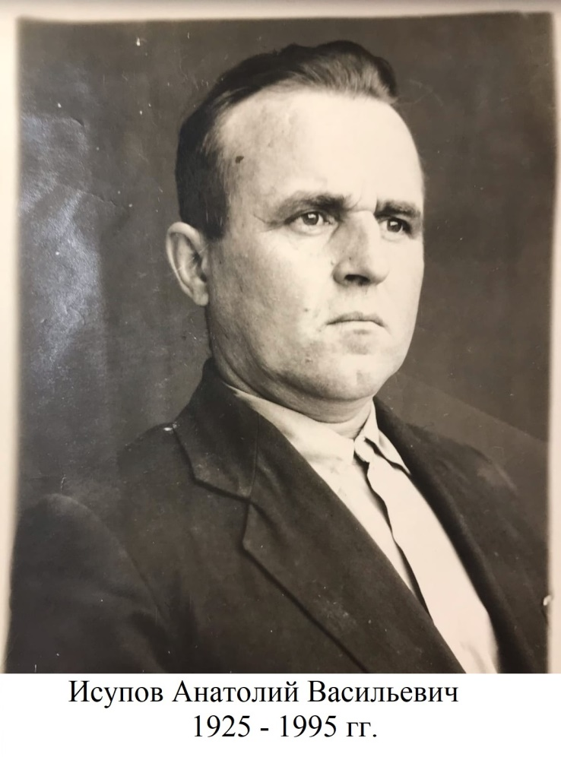
The war... It was a hard and anxious time, but people spared no effort, no self for the sake of our future. They did everything so that we could live better and happier life than they did. Everyone did one’s best to bring Victory Day closer. There is no family in this country without the Great War traces.
The war broke out in this country unexpectedly, insidiously and brutally. My great-grandfather - Anatoly Isupov - went to the front in late August of 1943 been an eighteen-year-old boy according to his certificate of participation in the Great Patriotic War. Fighting in the heat of the battle on the Dnepr River as part of 113 rifle regiment, he was concussed and fell into fascist captivity. But hard trials - hunger, cold, wounds - did not break him. Together with his comrades he escaped from the captivity. For his feats my great-grandfather was awarded several medals and the Order of the Great Patriotic War of the 2nd degree. After demobilization, the life of twenty-year-old Anatoly Isupov seemed to be starting again. Before he retired he had been working as a blacksmith on the collective farm "Russia" for many years.
The war will end only when the last one who fell in it is buried. Today only ought to take care of those who survived and remember. Memory is the only thing that connects the past and the future, you and them. Turning the pages of my great-grandfather’s life I can see the pages of my history.

The third story
The author – Ekaterina Ispolatova
My father's relatives lived in the Tver (Kalinin) region. I think that there is no family in this region that can forget about the Great Patriotic War. In the Kalinin front, the Red army repulsed one of the Wehrmacht main attacks during the defense of Moscow. The Battle of Rzhev (117 km from Tver) is marked in Soviet history as one of the longest and bloodiest battles. That battle forced enemies to transfer armies from Stalingrad. None of my great-grandparents could stay away, and all of them, and their brothers, and sisters were in the Red Army.
My great grandmother Vera Arsenyevna Sharabaeva was a radiotelegraph operator. Her three brothers died in the war. Other great-grandmother Klavdiya Mikhailovna Usatkina was a cook in a field hospital in a tank army. I have her picture:
My great-grandfather had already served in the army before the war broke out. His division was formed in Kazakhstan in 1941. One day the division commander told them that they would go to a wild country to carry out a combat mission. That’s how my great -grandfather Leonid Ivanovich Ispolatov found himself among the Soviet troops in Iran. But Iran did not seem to him to be a backward country at all. There were beautiful oriental buildings and electric wires hidden underground.
Little was known about the other great-grandfather Vasily Ivanovich Pavlov. He died when my grandmother was a schoolgirl, at that time she liked dolls more than stories about the war. Fortunately, my brother made a project about him last year. He found out that my great-grandfather had been awarded the Medal of Honor in the battle for the Ukranian village of Olkhovets and the Order of the Red Star in the battle for the Hungarian station of Banhida. I have a picture of him at the beginning of the war:
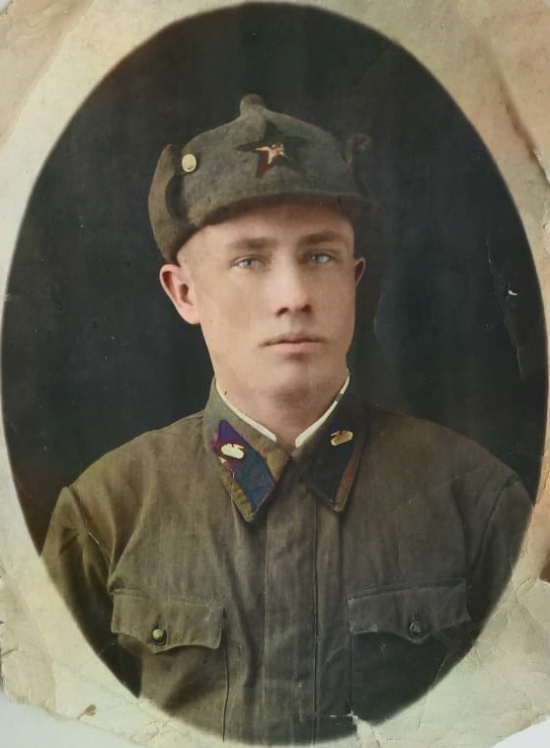
And in this photo my great grandfather and his regiment mates are celebrating the end of the war in Vienna:
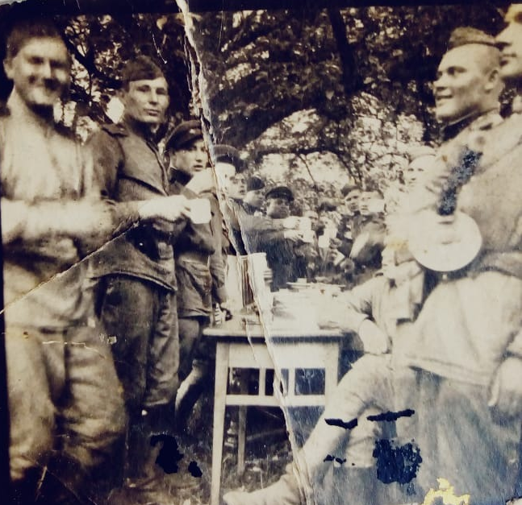
I ought to be thankful to my family for my life and for everything I have. Moreover, our great-grandfathers and great- grandmothers are passing away and the History may go away together with them. It depends on us not to let them be “gone by the wind”.
The fourth story
The author – Ekaterina Belova
The Great Patriotic war is pain, suffering, huge losses, tears, brotherhood, hope, strength and victory! It took millions of lives and became a tragedy for everyone. This is an event that should remain in the memory of every new generation in our World.
Every family ought to remember every person who put all the strength into winning that war. I want to tell you about all my family members who fought and achieved victory in the Great Patriotic war!
Two of my great-great-grandfathers fought at the front. They went through the entire war and survived. But, unfortunately, because of the severe injuries they had received during the war, they died within 2 years.
My great-grandfather, Vasiliy Afanasievich Belov, was born in 1911. He went through the entire war and lived for many years after the end of the war, and died in 1985. As my grandmother told me, in the post-war period, none of the participants in the war wanted to talk about their military path. This topic was closed for discussion, so we do not know much about his feats in the wartime.
My other great-grandfather, Alexander Nikiforovich Gorlov. He was born in 1920, went through the entire war, and was a member of the Communist party. In the war, he was severely wounded in a battle in his left leg. At the front, they put a tourniquet on his leg for too long, his leg became very numb, and he was commissioned. After the war, there were severe complications from injuries and eventually he became a disabled ( group 2) of the Great Patriotic War.
My great-grandmother, Alexandra Sergeevna Gorlova (nee Antonova), was born in 1920. In 1941, she was in Moscow, working as a nanny. After the first military actions, she was sent to the frontline zone to dig trenches. After a while, all the army assistants were gathered into one team, where my great-grandmother started working in the front-line Laundry. The whole brigade wanted to help the army in the war, and they reached the front line! Upon returning to Moscow, her papers turned out to have been lost, so she could not prove that she had worked in the rear during the Great Patriotic War.
Without these brave people, my family would not exist! Each participant of the war gave us a present of the bright future and quiet life. We must remember, honor, respect, and thank these people forever. After all, without them, there would not be any of us!
Conclusion
There is hardly a family in our country which has not had a participant in that war. We are strongly convinced that time will pass but Russian people will still remember the great spirit and patriotism of our nation during those terrible years of war. Thanks to our families, we are aware of what it means to keep memory of your ancestors. We are happy that we’ll have something special to tell our children about the Great Patriotic war someday.
